Timeline Menu

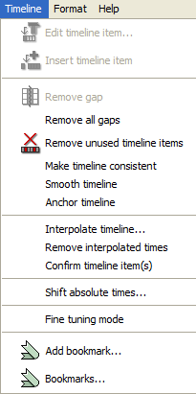

Timeline > Edit timeline item...
Opens a dialog to edit the absolute time value of the currently selected event:

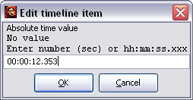

The absolute time value can either be entered as a decimal number (i.e. in seconds) or as hh:mm:ss.xxx. The entries:

181.23
00:03:01.23
03:01.230

for example all represent the same, namely: "3 minutes, 1 second and 230 milliseconds."

Timeline > Insert timeline item
Inserts a new time point to the left of the currently selected time point.

Before:
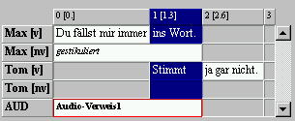

After:
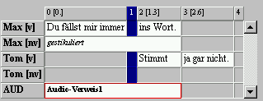

Timeline > Remove gap
Removes the currently selected gap from the time axis. A gap is a space between consecutive time points that does not contain an event. When calling up this menu item, the first of these two time points is removed and thereafter the rest of the transcription is moved to the left by one time point.

Before:
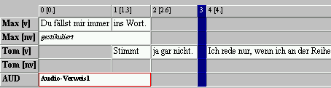

After:
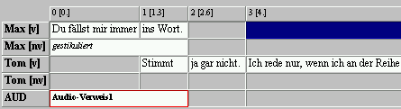

Timeline > Remove all gaps
Removes all gaps from the transcription.

Timeline > Remove unused timeline items
Removes all unused timeline items from the transcription. A timepoint is unused when no event starts or ends on it.

Before:
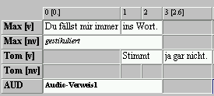
After:
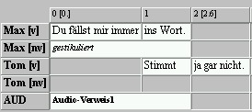

Timeline > Make timeline consistent
Checks the time axis for inconsistencies, i.e. after absolute time values. Absolute time values that do not fit into a monotonously growing sequence are removed.

Timeline > Smooth timeline...
Smooths the time axis, i.e. looks for time points whose absolute time values lie very close together and combines these to one time point. In the dialog an upper limit can be set for the maximum interval (in seconds). For this operation, the default value (one hundredth of a second) is useful for many purposes.

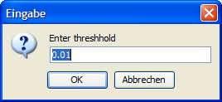

Timeline > Interpolate timeline...
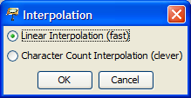

Interpolates the time axis, i.e. calculates an absolute time value for all time points that have not been assigned an absolute time value. Please note that the values calculated in this manner are only an estimate of the actual absolute time values of the time points in question. If more time points have been defined with an absolute time value, the value of the interpolation will be more accurate.
There are two methods of interpolation. For this, consider the following transcription in which no absolute time value is available at time point 2:

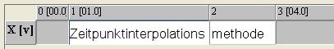

The method Linear Interpolation inserts missing absolute time values according to the number of time points that lie between the previous and the next time point with an absolute time value. In the example above time point 2 receives the value 1.0 + (4.0 – 1.0)/2 = 2.5:

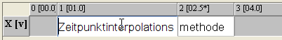

The method Character Count Interpolation, on the other hand, inserts missing absolute time values according to the symbols in the events in question. Events with longer descriptions are assigned to intervals of a longer duration.

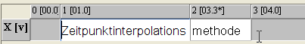

The second method leads to better results in most cases. Interpolated time values are marked with an Asterisk [03.3*] in the timeline of the musical score.

Timeline > Remove interpolated times
Removes absolute time values from the time axis that have been created by interpolating (see above).

Timeline > Confirm timeline item(s)
Confirms the absolute time values of all currently selected time points, i.e. sets their status from "interpolated" to "confirmed", if applicable. The Asterisk will then disappear and the time points in question will no longer be removed when executing "Remove interpolated times".

Timeline > Shift absolute times...

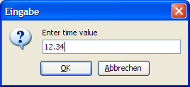

Moves all absolute time values in the time axis by the specified value. The value may also be negative.

Timeline > Add bookmark…
Adds a bookmark to a point on the time axis or allows the renaming of an already existing bookmark. A bookmark can facilitate finding significant sections of a transcription again (see Timeline > Bookmarks). Select the time point in question by clicking into it on the time axis. Then choose Timeline > Add bookmark.

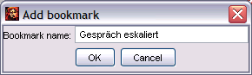

Enter a name for the bookmark in the window that appears or rename the bookmark and click OK upon completion of your entry. The name of the bookmark will appear in the time axis thereafter:

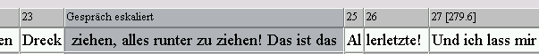

Timeline > Fine tuning mode
Activates or deactivates the mode for fine tuning the absolute time references. If the mode is turned on the behavior of the Editor will change as shown in the following:
- By scrolling, the absolute time value of a selected time point can be increased or decreased by 0.1 seconds.
- By pressing F1 only the first second of the currently selected time intervals is played.

Timeline > Bookmarks…
Opens a window with the selection of all set bookmarks.

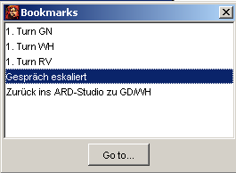

Select the section in the transcription that you would like to access and click Go to… .

